FOR IMMEDIATE RELEASE
Inquiries contact Leann Standish lstandish@sloma.org

SAN LUIS OBISPO MUSEUM OF ART TO PRESENT NEW MURAL BY BUNNIE REISS

San Luis Obispo, CA – June 30, 2026 The San Luis Obispo Museum of Art (SLOMA) is pleased to announce a new mural for 2026 to be painted by American mural artist Bunnie Reiss beginning on July 13th, 2026. The mural is expected to be finished by August 1st, 2024.

This new mural will replace the beloved Meter & Time by world-renowned muralist and street artist MOMO.

Bunnie Reiss's forthcoming mural for SLOMA draws from the native landscape of California's Central Coast, weaving together local birds and wildflowers in the bold, fluid visual language for which she is known. Spanning all of the exterior surfaces of the museum building, the work will feature species including Western Bluebird, California Scrub Jay, Hooded Oriole, Anna's Hummingbird, House Finch, and Orange Crowned Warbler alongside native blooms — California Poppy, Lupine, Baby Blue Eyes, Coyote Mint, Purple Owl's Clover, Solidago, and Common Goldfields. In Reiss's longtime practice of celebrating the natural world through pattern, symbolism, shared joy, the piece will bring an exuberant sense of place to SLOMA's exterior ahead of the museum's forthcoming expansion. Reiss’s mural will be on the building when SLOMA’s current 1010 Broad building transitions to an Education Center centered on community partnerships and programs for kids and families. As is typical for her practice, Reiss does not title her work until its completion.

"Bunnie Reiss brings such a generous and joyful spirit to everything she makes, and we couldn't be more excited to welcome her work onto our building. This mural is the latest in SLOMA's commitment to activating our exterior as a living canvas for the community — a rotating showcase for artists whose work sparks connection and invites people in. It feels especially meaningful as we look ahead to the next chapter for this museum and this building."
— Leann Standish, Director, San Luis Obispo Museum of Art

Meter & Time will begin to be painted over on July 5, 2026 in preparation for Bunnie’s installation.

About Bunnie Reiss
Bunnie Reiss was raised with the wide blue skies of Colorado, and often describes her childhood as similar to the song ‘Little Fluffy Clouds’ by The Orb. She has a large Polish/Russian family, so eating, loud talking, and community shaped her world. She was a tiny rebel with a large imagination and knew at a young age that she would build things much bigger than herself. She moved to rural Colorado, studied literature, and worked for NPR and other various publications, while quietly painting on the side. Magic, mysticism, nature, and the stars slowly crept into her consciousness, and she began almost obsessively studying anything she could get her hands on. Her need to travel and obtain information slowly pushed her all over the world, and she eventually left Colorado to relocate to San Francisco. Her 20+ years in The Bay Area included an MFA from San Francisco Arts Institute and years of creative incubation in wild streets full of weird art and people painting everywhere. She grew into herself, and found a community of artists that she would spend many years building, living and creating things together.
After a small stint in France and a few other areas around the US, Bunnie relocated to Los Angeles. Her busy life blossomed even more, taking her murals and art all over the world. Her time in Los Angeles was crucial to her development as a professional artist, but she began yearning for a more quiet life with space to grow. She eventually purchased her dream home in the Mojave desert, and has been slowly building up a 5-acre art farm affectionately known as Lilac Lane Farms. Her painting studio, animals, vegetable/flower garden and balance of life and art have helped her to imagine a world she never knew could be possible.
Bunnie has shown extensively in both the United States and around the world, in galleries, alternative spaces, bookstores, abandoned buildings, fields and forests, or any place that seems to need a little extra magic. Her brightly colored folk murals decorate many countries and can be found all over the world. Los Angeles, Mexico, Italy, Paris, India, Philippines, Detroit, Milwaukee, New York, San Francisco are just a few places you would likely stumble upon one.

About the San Luis Obispo Museum of Art
The San Luis Obispo Museum of Art (SLOMA) is an innovative and accessible museum located on California’s Central Coast. The museum presents an outstanding exhibitions program that features artists from California and around the world, as well as an ongoing series of dynamic events that engage visitors of all ages. SLOMA is located in downtown San Luis Obispo on the west end of Mission Plaza, at the heart of the city’s cultural corridor. A destination for art lovers and those just beginning to experience art alike, the museum provides a welcoming space and offers free admission to all. More information can be found at www.sloma.org.
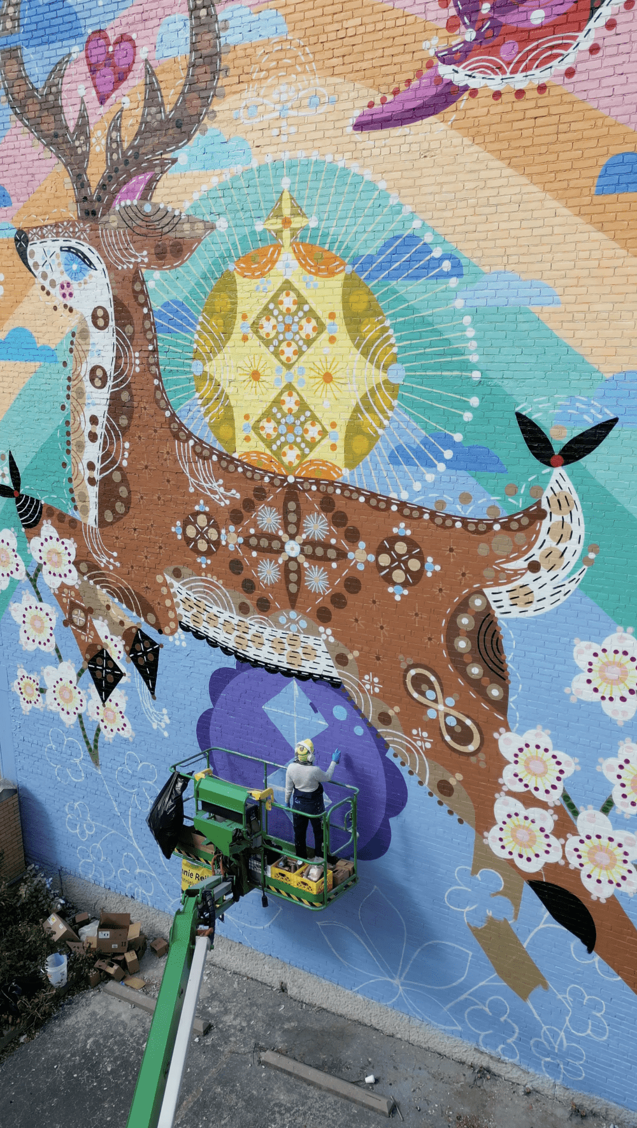

High-res images of past projects
available upon request

